

**KINGDOM OF LESOTHO**

**Ministry of Social Development**

# Project Closure Report

VAC HELPLINE SYSTEM

Submitted by



# 

Table of Contents

Project Closure Report 1

Executive Summary: 3

Scope Statement 3

2.     Challenges 5

Project Duration 5

Infrastructure Readiness 5

4.     Project Milestones 5

Risks to run the project and Recommendations. 6

Hardware Failure 6

Telephony Failure 6

Security Breach 6

Data privacy violation. 6

Retrospective. 6

Transfer to Operations 7

Project Completion Acceptance 7

## ****Executive Summary:****

One of the key components of Child Protection systems is the reporting mechanism by adults and children on incidents or risks of any abuse, violence, and exploitation happening against any child.

We have been tasked with developing, customizing, and deployment of a call tracking system. The system is to be used in receiving calls and capturing information that may lead to creating new cases. And following up on the cases until closure.

The BITZ ITC team would like to express our gratitude to all who took the time to speak to us during the inception phase exercise. This helped us come up with the Functional Requirement Document which has been guiding us through the customization phase.

## ****Scope Statement****

1. Project Accomplishments

We have covered all aspects of the scope as described below.

|  |  |
| --- | --- |
| **SCOPE ITEM** | **#STATUS** |
| The system should be able to receive calls for VAC on the toll-free number through an E1 channel. The Telephony provider could only offer SIP (A more modern technology) within the set timelines. However to enable a successful go live we have proposed to use the existing PABX. | Ongoing / Should be complete before the end of the week. |
| The system should be developed based on open-source standards and technologies preferably on major frameworks such as Laravel, Django, and Spring, etc. The process shall be managed and code shared on a code repository such as GitHub with clear documentation on deployment and integrations. | The system is been developed using PHP / Native Java Script. A git repository has been created and access will be provided during the Maintenance Period. |
| Build capacity of the end-user teams to be able to make minor adjustments to the system (configurable modules where possible e.g. case categories, SIP accounts,) and to manage the system after it has been handed over. | The system is now customizable Users can be able to add & Remove some attributes. |
| Develop a universal documented API to enable integration with other 3rd Party systems which will come in the second phase.  API will enable a secure integration with any system. As it will expose data for consumption in two ways. External systems will be allowed to consume data from the CHL; the CHL will also be able to access and use data produced by other systems. | The system has been designed with Channels. This will make it easy to integrate with other sources of information as well as push data into other systems |
| The solution should be able to handle case distribution, routing, escalation based on roles & permissions regarding access for reported cases. This should include follow-ups, case prioritization as well as case closure by providing necessary assistance to the clients who reach out to the Call Center. | The system has been designed with a very robust case management module. We have formed logic to intelligently determine the follow-up questions, Allowing for prioritization and also escalating the cases to the next level. |
| Provide dashboard & Reports, real-time call, and case analytics with key metrics based on the set Case Categories, Demographics, System Users, Calls, and Call activities. | The system has been designed to provide a Dashboard with key metrics. The dashboard also has filters that can be used to display only data that a user wants. |
| Design and documentation such as:  a.     User Training Manual and Guide  b.     Technical system documentation such as system architecture and technical specifications documentation, system manuals including quick troubleshooting guides and summaries, system administration manuals, guides, configuration, backup and restore procedure manuals | All Documentation has already been designed is ready to be re-used. |
| Plan and conduct training for: Helpline staff, Helpline Supervisors, and local helpline nominated IT focal points and other relevant staff identified. | Training has been conducted all Helpline users have been trained. |
| Provide technical support and ongoing routine maintenance for the Helpline, including regular software updates/upgrades for 6 months after the commissioning of the system. | This will be implemented after going live. |
| Implement security protocols for call & case data and design & set up remote backup, restore & recovery plans, procedures, and systems based on the developed Functional Requirements Document (FRD) taking into consideration confidentiality of the data. | The Backup concept is already developed and will be implemented during the maintenance period. |
| Deploy the enhancements on the hosting platform and secure it with a Secure Sockets Layer (SSL) certificate for added security. | The system has been deployed and is ready for the SSL installation. |

## ****2.     Challenges****

### Project Duration

The project duration was set to four weeks. This was a very short period considering that the project had to be done 100% Remote.

### Infrastructure Readiness

The telephony setup has not been straightforward. As this is key to the success of the system. We have recommended that the center uses the existing PABX as we wait for the SIP Trunk application.

The server is also noted to be of very low specs. As this data will grow it is recommended that the center includes in the annual financial plan procurement of a server within the period.

## ****4.     Project Milestones****

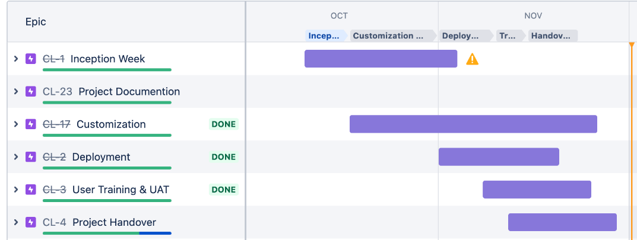

## Risks and Recommendations.

### Hardware Failure

If the hardware fails, the helpline can experience a total loss of Data. Our team together with IT must ensure daily replication & backup of the server. Regularly scheduled drills will be conducted to verify the quality of the data integrity.

### Telephony Failure

Sometimes due to Internet Issues or Equipment, the calls may malfunction. The center is advised to always have a GSM VoIP PABX ready to connect to the server. This will ensure that the system has adequate up-time.

### Security Breach

The ministry is requested to ensure that the server is protected from possible security breaches by installing a firewall that automatically filters out know hackers.

### Data privacy violation.

The system tries to restrict data only to creators, however, in cases where our restriction has been bypassed. The SPOC (single point of contact can inform us by raining a ticket.

### 

## ****Retrospective.****

Generally, the teams have been very good at executing their mandate. There has been no major concern during the project time.

# Transfer to Operations

At the end of the project, it is critical to Identify Key Personnel who will take over the day-to-day operation of the system. The following are the key areas.

|  |  |  |
| --- | --- | --- |
| **Role** | **Name** | **Transition Date** |
| Functional Owner( Ideally someone in charge of the call center) |  | 03 Dec 2021 |
| Service Owner (Ideally someone in charge of the IT part of the business this will also be the single point of contact (SPOC) for any malfunction are need to repair the software. |  | 03 Dec 2021 |
| Client Project Lead (This should be a business leader or person who has been leading the project activities on the client side. |  | 03 Dec 2021 |

## ****Project Completion Acceptance****

|  |  |  |  |
| --- | --- | --- | --- |
| **Project Role** | **Name** | **Signature (Electronic is acceptable)** | **Date** |
| Executive Sponsor |  |  |  |
| Functional Owner |  |  |  |
| Service Owner |  |  |  |
| Vendor Manager |  |  |  |
| Project Manager |  |  |  |